

F241 Microprocessors & Interfacing

Project Report

Group 7

Batch Weighing Machine

2020-21

**Group Members :**

| **ID** | **Name** |
| --- | --- |
| 2019A7PS0043G | Nishant Vikas Sarangdhar |
| 2019A7PS0086G | Shubham Rajnish Gandhi |
| 2019AAPS0315G | Suhaas Mahajan |
| 2019A3PS0373G | Saksham Shivshankar Kamath |
| 2019AAPS0489G | Rishabh Garg |
| 2019A8PS0509G | Shivang Thalpiyal |

**Project done under the guidance of Dr. K.R. Anupama at**

**Birla Institute of Technology & Sciences, Goa**



# **TABLE OF CONTENTS**

# 

**TABLE OF CONTENTS** **3**

**PROBLEM STATEMENT** **4**

**USER REQUIREMENTS AND TECHNICAL SPECIFICATIONS** **5**

**ASSUMPTIONS AND JUSTIFICATIONS** **5**

Assumptions 5

Justification 5

**COMPONENTS USED WITH JUSTIFICATION WHEREVER REQUIRED** **6**

**ADDRESS MAP** **8**

Memory Map 8

I/O Map 8

**DESIGN** **9**

**FLOWCHARTS** **10**

Main Program 10

WEIGH_ISR 11

ADC_ISR 12

OFFA_ISR 13

**VARIATIONS IN PROTEUS IMPLEMENTATION WITH JUSTIFICATION** **14**

**CODE ACCORDING TO ON-PAPER DESIGN** **15**

**LIST OF ATTACHMENTS** **26**

# 

# 

# PROBLEM STATEMENT

A microprocessor based system is to be designed as a batch weighing machine.

* The system is interfaced to three load cells by means of an 8 bit A/D converter.
* The conditioned output of the load cells is given by the equation:
  + *Vout = 0.025 x weight (kg)*
* The system monitors the output of the load cells and finds out the total weight by taking the average of the three values that are sensed by each load cell.
* This value is displayed on a seven-segment display.
* When this value exceeds 99 kgs, an output port, which is connected to a relay, is switched on to sound an alarm.
* Once the objects are placed on the load cell user presses a switch labeled **weigh**, this starts the weighing process
* There is also an alarm off switch to turn off the alarm

# USER REQUIREMENTS AND TECHNICAL SPECIFICATIONS

A microprocessor-based system is to be designed as a batch weighing machine.

* The system is interfaced to three load cells by means of an 8-bit A/D converter.
* The conditioned output of the load cells is given by the equation: Vout = 0.025 x weight (Kgs.)
* The system monitors the output of the load cells and finds out the total weight by taking the average of the three values that are sensed by each load cell.
* This value is displayed on a seven-segment display.
* When this value exceeds 99 kgs, an output port, which is connected to a relay, is switched on to sound an alarm.
* Once the objects are placed on the load cell, the user presses a switch labeled weigh.

# ASSUMPTIONS AND JUSTIFICATIONS

### Assumptions

1. User always presses the alarm off switch, before moving on to the next measurement, if the alarm is ringing due to previous measurements
2. If the weight exceeds 99kgs, **99** is displayed on the 7-segment display & buzzer goes off.
3. At a time only data from one load cell is being processed
4. It can measure with a least count of 1kg.

### Justification

1. We display 99 as it is the maximum possible weight as per the problem statement
2. The ADC can process one analog input at a time and convert it into digital output one at a time only. Our design is an optimum design. Thus, we have used only 1 ADC.
3. We are making use of BSR functionality of port C, hence we are able to accommodate the Input output devices in 1 8255.

# COMPONENTS USED WITH JUSTIFICATION WHEREVER REQUIRED

| **DEVICE** | **NOS.** | **USE** |
| --- | --- | --- |
| 8255 - PPI | 1 | Used for interfacing with I/O devices like load cell and 7-segment display |
| 8259 -Interrupt Controller | 1 | Used for managing the control of various interrupts |
| 6116 - RAM | 2 | Used for external storage |
| 2716 - ROM | 4 | Stores the code, IVT |
| 8284- Clock generator | 1 | Used for generating the clock pulse taking the input from 15MHz Crystal |
| 8086 | 1 | Microprocessor used to perform calculations (average of 3 weights) |
| 8254- Programmable Interval Timer | 1 | Used to generate 1MHz clock pulse using 5MHz pulse. (reason :- ADC requires 1MHz input) |
| ADC-0808N | 1 | Converts analog input of load sensor to digital output processed by 8086. |
| 74LS138- 3x8 Decoder. | 2 | For memory and I/O decoding. |
| 74LS373- Latch | 3 | To latch the address given on the AD bus. |
| 74LS245- Buffer | 2 | To boost up the bus signals. |
| TIP120- Darlington configuration | 1 | To amplify the current from 8255 port. Amplified current is required by relay. |
| G2RG- Relay | 1 | To connect or disconnect the buzzer from the rest of the circuit. |
| 12V Buzzer | 1 | It rings when the average weight exceeds 99kg. |
| 74LS47 decoder | 2 | BCD to seven segment decoder. |
| TDSG 5150- 7 segment display | 2 | The average weight is displayed on it if it's less than 99 kg. |
| M74HC32- Quad 2 input OR gates | 3 | Used for generating various chip select and control signals. |
| Load Sensors | 3 | ***Vout = 0.025 x weight(kg)*** |
| LS244- octal buffer | 1 | Used for generating control signals. |

# ADDRESS MAP

### Memory Map

| **DEVICE** | **START ADDR.** | **END ADDR.** |
| --- | --- | --- |
| ROM - 1 | 00000 h | 00FFF h |
| RAM | 01000 h | 01FFF h |
| ROM - 2 | FF000 h | FFFFF h |

### 

### I/O Map

| **DEVICE** | **START ADDR.** | **END ADDR.** |
| --- | --- | --- |
| 8255 - PPI | 00 h | 06 h |
| 8254 - Interval Timer | 20 h | 26 h |
| 8259 - Interrupt Controller | 30 h | 32 h |

# 

# 

# 

# DESIGN

Complete design shown with proper labelling (ON-PAPER DESIGN attached as both PPT and PDF files. Please check zip folder)

# FLOWCHARTS

### Main Program

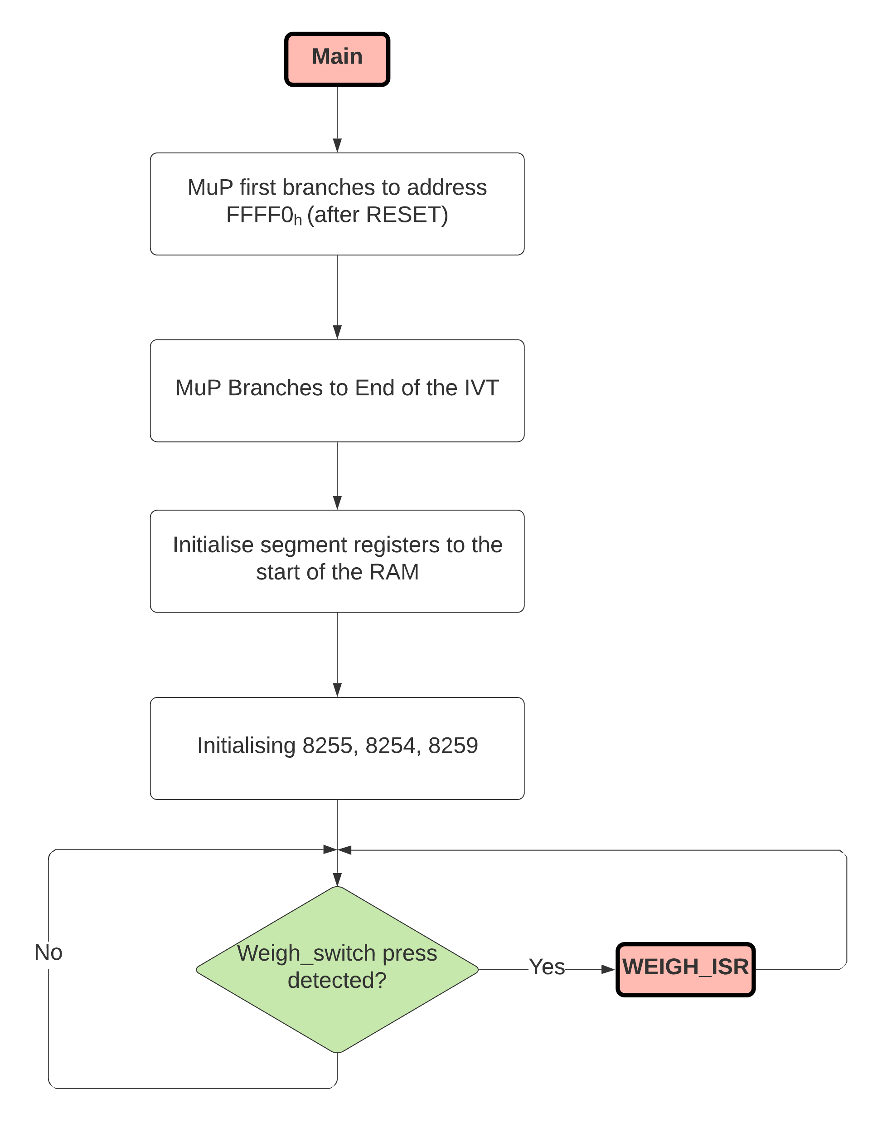

### WEIGH_ISR

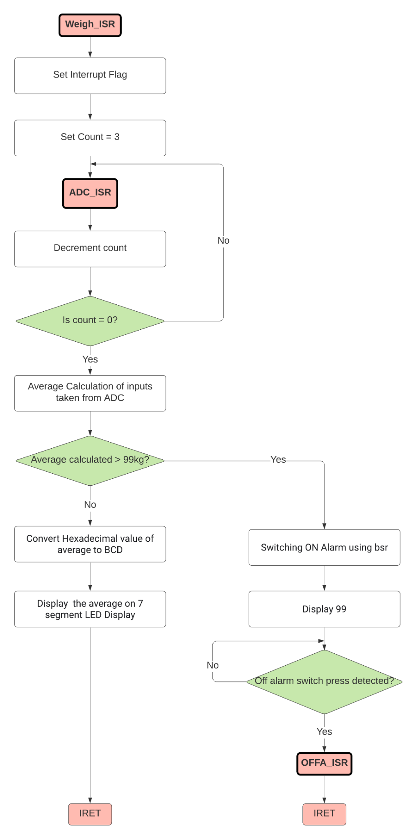

### ADC_ISR

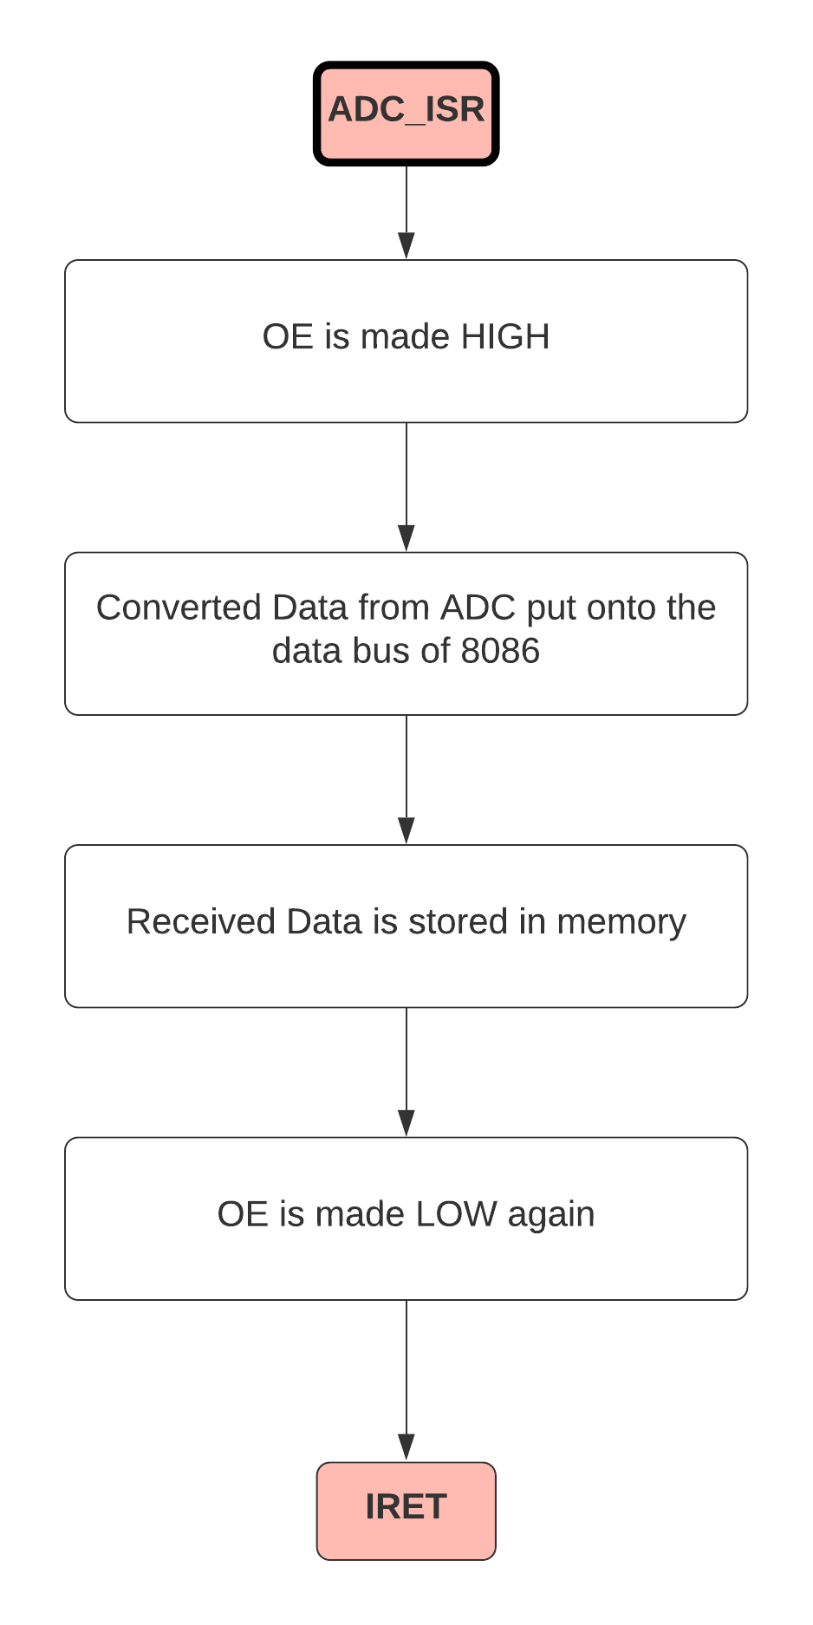

### OFFA_ISR

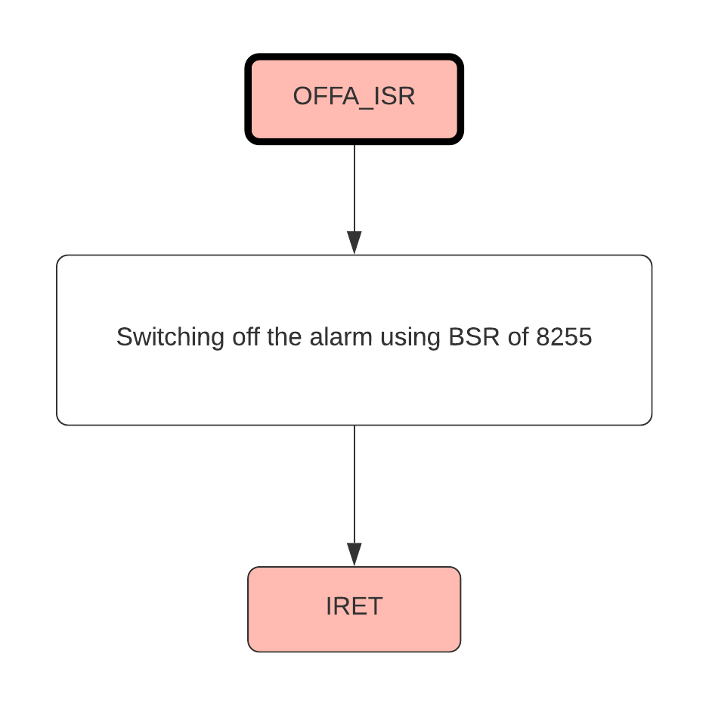

# VARIATIONS IN PROTEUS IMPLEMENTATION WITH JUSTIFICATION

* 8284 and 8254 are not available. The clock of 8086 is directly provided as 5 MHz.
* Instead of 8254, 8253 is used, the input clock fed in is 2.5MHz. This generates 500KHz , instead of 1MHz which is fed into ADC.
* We are using two 8255’s in Proteus as 8259 is not available. The first: 8255A is used for taking in the values from ADC. The second : 8255B has connections to 7 segment displays. WEIGH_SWITCH gets connected to NMI of 8086. PC0 has EOC of ADC.
* Load sensors are not available, hence variable DC voltage sources are used in place of load cells.
* 2716 is not available in proteus hence we used 2732.

# CODE ACCORDING TO ON-PAPER DESIGN

#make_bin#

*; set loading address, .bin file will be loaded to this address:*

#LOAD_SEGMENT=0000h#

#LOAD_OFFSET=0000h#

*; set entry point:*

#CS=0000h# *; same as loading segment*

#IP=0000h# *; same as loading offset*

*; set segment registers*

#DS=0000h# *; same as loading segment*

#ES=0000h# *; same as loading segment*

*; set stack*

#SS=0000h# *; same as loading segment*

#SP=FFFEh# *; set to top of loading segment*

*; set general registers*

#AX=0000h#

#BX=0000h#

#CX=0000h#

#DX=0000h#

#SI=0000h#

#DI=0000h#

#BP=0000h#

*;Jump to start of code*

JMP ST

NOP

*;NOP is added so that we get proper intervals of 4 bytes, jmp st1 will be 3 bytes and nop will be 1 byte*

DW 114 DUP (0) *; int 01h to 39h unused // 39h * 2 = 114d*

*;Interrupt for off alarm at vector 40h*

DW OFFA_ISR

DW 0000H

*;Interrupt for weigh switch at vector 41h*

DW WEIGH_ISR

DW 0000H

*;Interrupt for eoc at vector 42h keeping cs as 0000 only*

DW ADC_ISR

DW 0000H

*; int 43h to FFh are unused*

*; FFH-43H+1H = BDH = 189D, 189D * 2D = 378D*

DW 378 DUP (0)

*;Defining some Labels*

*;8255*

PORTA1 EQU 00H

PORTB1 EQU 02H

PORTC1 EQU 04H

CREG1 EQU 06H

*;8254*

CNT3 EQU 20H

CREG3 EQU 26H

*;8259*

A82591 EQU 30H

A82592 EQU 32H

*;Main Program*

ST: CLI *; Clear interrupt flag so that no interrupts are recieved during initialization*

*;Intialize ds, es,ss to start of RAM*

MOV AX, 1000H

MOV DS,AX

MOV ES,AX

MOV SS,AX

MOV SI,AX *; used for storing weights measured temporarily*

*;Initializing ports*

*;For 8255 Port A & B are inputs Port C is output*

MOV AL, 10010010B *;8255*

OUT CREG1,AL

*;8254 - counter 0, read write lsb and msb, mode 3, binary*

MOV AL,00110110B

OUT CREG3,AL *;8254 Control Word*

MOV AL,05H

OUT CNT3,AL *;Giving count of 5 to counter0 of 8254*

MOV AL, 00H

OUT CNT3, AL

*;8259 initialization*

MOV AL, 00010011B *;8259 ICW1*

OUT A82591,AL

MOV AL, 01000000B *;8259 ICW2, starting interrupt vector is 40H*

OUT A82592,AL

MOV AL, 00000001B *;8259 ICW4, since we dont have a slave, ICW3 is skipped*

OUT A82592,AL

MOV AL, 11111000B *;8259 OCW1 only IR0,IR1,IR2 are enabled*

OUT A82592,AL

*;Setting 8255 to i/o mode*

MOV AL, 10010010B *;8255*

OUT CREG1,AL

MOV AL, 00H *; display 00 by default*

OUT PORTA1,AL

STI *;Set interrupt flag to enable receiving interrupts*

INF1: JMP INF1 *; Waiting for user to press the weigh switch for measurement*

WEIGH_ISR:

STI

*; Taking inputs from adc using 8255*

*; We have to take 3 values*

MOV CX,0003H

MOV DH,00H

MOV DI,0000H

*; Ports need to be reconfigured*

wloop: MOV AL, DH

OUT PORTC1, AL

*; Making ale 1 from BSR mode*

MOV AL, 00001011B

OUT CREG1, AL

NOP

*; Making soc 1 from BSR mode*

MOV AL, 00001001B

OUT CREG1, AL

*; Make ale 0 using bsr mode, since ALE must be active only for 1 clock cycle*

MOV AL, 00001010B

OUT CREG1, AL

NOP

*; Make soc 0 using bsr mode, since SOC must be active only for 1 clock cycle*

MOV AL, 00001000B

OUT CREG1, AL

*;Wait for EOC to be received from the ADC*

HLT

*; Looping*

INC DH *; for taking in next analog input from load cell*

INC DI

LOOP wloop

*; Average calculation*

MOV SI,0000H

CLD

MOV AH,00H

MOV BX,0000H

MOV CX,0003H

LLOOP: LODSB

ADD BX,AX

LOOP LLOOP

MOV AX,BX

MOV BL,3

DIV BL

*; Compare with 99*

*;IF WEIGHT<=99KG then it is valid*

CMP AL,99

JBE VALI

*;Setting 8255 to i/o mode*

MOV AL, 10010010B *;8255*

OUT CREG1,AL

*;If weight > 99*

MOV AL, 99H *; If weight exceeds 99kgs, we display 99*

OUT PORTA1,AL

*; Switching ON Alarm using bsr*

MOV AL,00001111B

OUT CREG1,AL

HLT *; Waiting for user to turn off alarm manually, this is part of assumption*

JMP INVALI

*; convert from hex to bcd*

VALI: MOV BL,AL

MOV AL,0

HTB: ADD AL,01

DAA

DEC BL

JNZ HTB

*; Setting 8255 to input/output mode*

MOV AL, 10010010B *;8255*

OUT CREG1,AL

*; display bcd*

OUT PORTA1,AL

INVALI:

*;ending interrupt using Non-Specific EOI*

MOV AL, 00100000b

OUT A82591,AL

IRET

OFFA_ISR:

*; Making alarm off using bsr*

MOV AL,00001110B

OUT CREG1,AL

*;ending interrupt using Non-Specific EOI*

MOV AL, 00100000b

OUT A82591,AL

IRET

ADC_ISR:

*; Making OE 1 using bsr for 8255*

MOV AL,00001101B

OUT CREG1,AL

*; Taking Inputs from Port B*

*; Setting 8255 to i/o mode*

MOV AL, 10010010B *;8255*

OUT CREG1,AL

IN AL, PORTB1

MOV [DI], AL

MOV AL,00001100B*; Making OE low again*

OUT CREG1,AL

*;ending interrupt using Non-Specific EOI*

MOV AL, 00100000b

OUT A82591,AL

IRET

# LIST OF ATTACHMENTS

1. Complete Hardware Design
2. Manuals (all manual texts are clickable links)
3. [74LS47](https://drive.google.com/file/d/17ee5lpGrQC4bjoX9IlPk-tUzmpBhh4kO/view?usp=sharing)
4. [74LS373](https://drive.google.com/file/d/1ugi9me2bbePNkNXEd0cIXPfgmY-Zd-T-/view?usp=sharing)
5. [8086](https://drive.google.com/file/d/1ahMs6ok2fdG1hN7pAOdR87QOsl1ydk09/view?usp=sharing)
6. [8255A](https://drive.google.com/file/d/1SmL_fOwAEXB70x4IerH2UF46GgnFBTq4/view?usp=sharing)
7. [8259A](https://drive.google.com/file/d/1wrJuUJpV5leywE-1ndw5u1pHF0zQHy64/view?usp=sharing)
8. [8284b](https://drive.google.com/file/d/19UQ_i21YTTUKjQ2j3IenuvfsZ53CrvRI/view?usp=sharing)
9. [ADC0808](https://drive.google.com/file/d/1-nLF8gueSYzr23O0Kol83r38Af73a1qM/view?usp=sharing)
10. [Buzzer](https://drive.google.com/file/d/1jblDlVLsfnpdnDCA_Rtm5erm9GCtgsS6/view?usp=sharing)
11. [Quad 2 input OR Gate](https://drive.google.com/file/d/1jblDlVLsfnpdnDCA_Rtm5erm9GCtgsS6/view?usp=sharing)
12. [Relay G2RG](https://drive.google.com/file/d/1FjDvcIEuxe5EC7BIcX5y72J2rJtsjy_i/view?usp=sharing)
13. Proteus File -
14. EMU8086 ASM files -
15. Binary file after assembly -